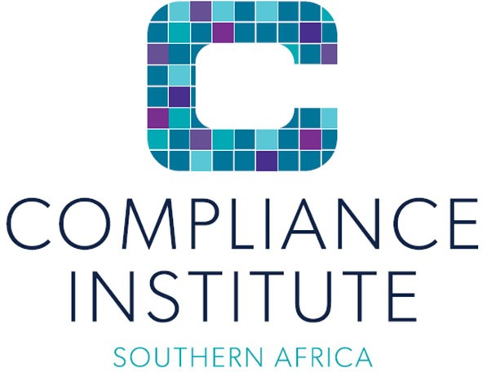

# COMPLIANCE MONITORING

# Training outline

# 

|  |  |  |  |  |
| --- | --- | --- | --- | --- |
| **Cost per person Incl. vat** | **CPD Points and Accreditation** | **Accreditations/Partnerships**  **/Memberships** | **Method of Delivery / Format** | **Duration** |
| Refer to the latest advertised events for current rates or as quoted | 12 hours | n/a | Virtual via Microsoft Teams | 3 days – 4 hrs per day |

# Course Objectives

Compliance Monitoring forms the final phase in the compliance risk management process. Monitoring closes the loop which completes the compliance cycle, it provides feedback on the effectiveness of the management of compliance risks and identifies areas of weakness that need to be improved or enhanced. It is therefore highly recommended that individuals should have completed the Introduction to Compliance Management and the Compliance Risk Management Plan courses before registering for the Compliance Monitoring course.

After attending the course, attendees will:

* Understand compliance monitoring best practice and where applicable, legislated requirements.
* Know how to identify the primary objectives of compliance monitoring.
* Understand the form and methods of monitoring and which methods to use in different scenarios.
* Know how to identify the key role-players and their respective monitoring focus areas.
* Understand the concept of combined assurance and how this may impact on compliance monitoring.

# Prerequisites

We highly recommend that attendees have an understanding of the GACP and have a foundational understanding of the content of – or attended the following course:

* Introduction to compliance
* CRMP’s
* Control Identification and risk assessment

**What is covered?**

# Understand compliance monitoring best practice and where applicable, legislated requirements.

# Know how to identify the primary objectives of compliance monitoring.

# Understand the form and methods of monitoring and which methods to use in different scenarios.

# Know how to identify the key role-players and their respective monitoring focus areas.

# Understand the concept of combined assurance and how this may impact on compliance monitoring.

**Detailed outline**

# • The methodology for the monitoring of compliance by regulators

# • The methodology for compliance monitoring by management

# • The methodology for compliance monitoring by the compliance officer

# • The starting point of compliance monitoring

# • Independent monitoring

# • Effectiveness reviews

# • Materiality Sampling

# • Statistical sampling and non-statistical sampling

# • Working papers

# • The compliance reports

# • Recommendations that should be addressed in the compliance report

# • The review process and the relevant role players

# • Issues Log

# • The review process to evaluate the implementation of the Compliance Risk Management Plans throughout your organization

# Format of the course

* The training is held in a classroom style, either virtually or face‐to‐face.
* Theoretical training.
* Case studies form part of the learning process.

# Who should attend

• Compliance officers.

• Individuals in a compliance role tasked with monitoring responsibilities.

• Compliance monitoring specialists.

• Individuals in an internal audit role.

# ****Bio of presenter/s:****

# A person smiling for the camera Description automatically generated with medium confidenceDaryl Glass

Daryl worked at the Liberty Group between 1992 and 2007 and served in various capacities including as Head of Forensic Services and Head of Group Compliance and Group Compliance Officer for all entities within the Group.

Since 2007, Daryl has run a business consultancy practice whose main focus is on Governance, Risk, Compliance and Forensic services. He has provided services to a broad range of South African and international clients within both the private and private sectors across various industries. Daryl’s focus is to equip and enable organisations, their governing bodies and management to efficiently and effectively manage all forms of risk and meet relevant leading practice requirements. He led the development of the Public Sector Compliance Framework as a consultant to National Treasury.

Daryl participates extensively in the development and delivery of the core compliance training programmes of the Compliance Institute of Southern Africa and also previously served as a Director of the Institute between 1999 and 2006. Daryl has and does serve in various capacities on or as an advisor to the boards of several other organisations.

Daryl holds the CProf (SA) designation and has a BCompt, MBA and Post-graduate diploma in Compliance Management.