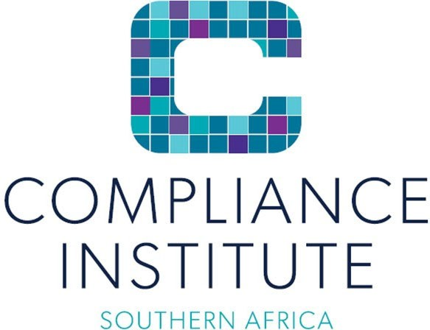

GENERALLY ACCEPTED COMPLIANCE PRACTICE (GACP)

Training outline

Cost per person Incl. vat | CPD Points and Accreditation | Accreditations/Partnerships  /Memberships | Method of Delivery  / Format | Duration
Refer to the | 8 hours | n/a | Virtual via | 2 days – 4
latest |  |  | Microsoft | hrs per day
advertised events for |  |  | Teams
current rates or as quoted

Course Objectives
The main objective of the course is to create a practical understanding of the Generally Accepted Compliance Practice Framework (GACP), including the Principles, Standards and Guidelines contained therein. This will assist participants in effectively aligning their compliance policies; framework/charters; structures, processes and compliance services to the GACPF with appropriate consideration of their organization, industry and environment.

The H1, 2023 training of the GACP will also highlight the key changes to the GACP from the 2018 to the 2023 version of the GACP, which will be launched in July 2023.

Course Approach and Content
The course will focus on the application of the GACP through facilitated discussions, practical exercises and sharing of experiences focusing on the key aspects of the GACP Principles, Standards and Guidelines relating to:

Compliance Governance

- Understanding the difference between a policy and framework / charter.
- Why there are minimum standards for the compliance policy and framework/charter and how the omission of key aspects will have a negative effect on the effectiveness and adequacy of the compliance function and compliance processes.
- Developing/ updating compliance policies and frameworks/charters.

Structures

- Governance Structures
- Consider different governance structure options and models.
- Identifying the best fit for an organisation based on the strategy, environment and industry.
- Discussions on how the structure should address independence, conflict of interest, authority for compliance functions and resourcing.
- Compliance Function Structures
- Consider the key deliverables of a compliance function.
- Assess whether existing structures allow these deliverables to be met.
- Consider and discuss shortfalls and issues experienced by compliance functions and how these could be overcome.

Compliance Roles & Responsibilities
- Overview of the key roles and responsibilities within the governance and compliance structures.
- Consideration and discussion on how the roles and responsibilities of compliance functions should consider governance and compliance structures and vice versa.

Resourcing and Competencies
- How resources and competencies should complement the compliance function to meet deliverables.
- Ways to improve competencies and resourcing to meet deliverables.

Compliance Processes and Activities
- High-level overview of the key compliance processes and activities.
- Brief overview of the existing courses provided by CISA and where the processes and activities are dealt with in more detail within the other courses.
- Consideration and discussion of processes and activities that may or may not be performed directly by the compliance function e.g. training and complaints. How these are dealt with by different organisations and where compliance involvement should be.

Organisational Context and Culture

- How the organisational context and culture influences the compliance function’s independence, authority and value it can add to the organisation’s strategy on meeting compliance obligations.

Assessing the effectiveness of compliance structures and functions.

- Types of assessments and their advantages and disadvantages.
- Reviewing the effective implementation and application of the compliance policy, framework and processes.
- How assessments can lead to an improvement in the effectiveness and adequacy of the compliance function.
- Discussion on creating a roadmap to get compliance from the level of effectiveness the function is at present to where they want (or need) to be over a period in time.

Bio of presenter/s:

Henriëtte du Plessis

Henriëtte du Plessis is in the employ of HdP Consulting Services (Pty) Ltd and also acts as a consultant to the Compliance Institute of Southern Africa.

In addition to Compliance and Corporate Governance Certificates (UJ), she has a legal background (BLC (UP), LLB(UP) and LLM (UJ)) and has been awarded the CI SA’s Compliance Practitioner designation (CPrac (SA).

She has been a compliance officer for the last 20 years and gained her compliance reporting experience in various levels of large corporates as well as being an independent compliance consultant.

Her experience also extends to corporate governance.

