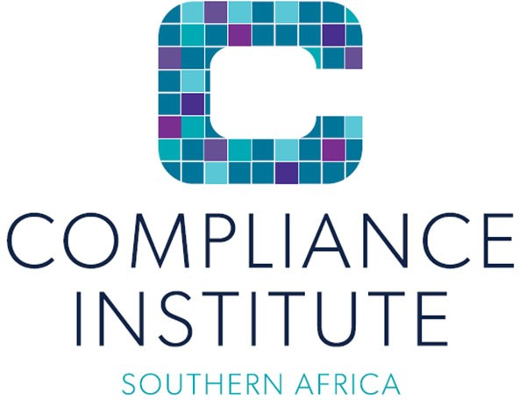

INTRODUCTION TO COMBINED ASSURANCE

Training outline

Cost per person Incl. vat | CPD Points and Accreditation | Accreditations/Partnerships  /Memberships | Method of Delivery / Format | Duration
Refer to the latest advertised events for current rates or as quoted | 12 hours | n/a | Virtual via Microsoft Teams | 2 sequential days & 3rd non-sequential day after 3 weeks for feedback

Course Objectives

Combined assurance is a co-ordinated approach that ensures all assurance activities provided by management, internal assurance providers, and external assurance providers adequately address significant risks facing an organisation, and suitable controls exist to mitigate these inherent risks to an acceptable level of residual risk.

Combined assurance involves the integration of assurance processes within an organisation in order to:

• maximise oversight of risk and governance and control efficiencies

• optimise the overall assurance provided to the audit committee

• reduce assurance overlap

• minimise assurance cost

• give due consideration to the organisation’s risk appetite.

Combined assurance is about assurance providers working closer together to ensure the right amount of assurance, in the right areas, from people with the best skills, in the most cost-effective way possible.

Prerequisites and study material
We highly recommend that attendees have an understanding of the GACP.

The Generally Accepted Compliance Practice framework (GACP) – members receive this as part of their membership or it may be purchased by non-members from accounts@compliancesa.com

Attendees should have an understanding of Risk Management and Assurance concepts in order to follow the terminology and methodology references.

Read through the case study material provided prior to the training.

Course delivery method
The training will be delivered in a webinar, allowing for facilitation and group discussion.
• Training slides
• Case Study
• Example of Combined Assurance Framework / Model

Detailed outline
Day 1 (9:00 to 15:00)
1. Background and benefits of combined assurance.
2. Reflect on the assurance provided by various assurance providers and lines of assurance / defence.
3. Evaluate and reflect on the effectiveness, relevance, and adequacy of combined assurance frameworks.
4. Describe the process, and role players, in compiling a combined assurance framework.
5. Compilation of a Combined Assurance Framework.
6. Implementation of a Combined Assurance Framework.
7. Establishment of a Combined Assurance Forum.
8. Conducting a due diligence assessment to determine the level of reliance to be placed on individual assurance providers.
9. Establishment of a comprehensive combined assurance universe (identify all assurance / auditable units).
10. Prioritising the combined assurance universe and determining the assurance need for each identified assurance unit in the universe.
11. The Conduct of assurance by individual assurance providers.
12. Integration of the results of individual assurance providers to a Combined Assurance Plan.
13. Combined Assurance Reporting.
14. Residual Risk per individual assurance unit.
15. Individual assurance provider, and consolidated combined assurance agreed management action plan and tracking.

Day 2 (9:00 to 12:00)
1. Combined Assurance Practical Objectives
2. Discussion of Case Study
3. Discussion of Combined Assurance Tool to complete the Case Study
4. Discussion of Deliverables (included in combined assurance tool):
• Documented Combined Assurance Universe.
• Assurance Need (Risk Assessment, Control Assessment and Consideration of Needs Assessment factors)
• Mapping of the Combined Assurance universe to all assurance providers.
• Compilation of a comprehensive Combined Assurance Plan.
• Inclusion of results of various assurance providers.
• Residual Risk per individual assurance unit.
5. Review of Combined Assurance Forum Charter (draft provided which require enhancement)
6. Review of Combined Assurance Charter (draft provided which require enhancement)
7. Conduct of Combined Assurance Reliance Assessment (case study information provided for assessment to be conducted)

Day 3 (9:00 to 12:00)
1. Feedback regarding the participants submission of deliverables as documented in Combined Assurance Tool.
2. Feedback regarding the participants submission of Combined Assurance Forum Charter
3. Feedback regarding the participants submission of Combined Assurance Charter
4. Feedback regarding the participants submission of Combined Assurance Reliance Assessment

Who should attend
• All Assurance Providers
• Management (Governance related positions)
• Compliance Officers
• Internal Auditors
• Risk Managers
• Company Secretaries etc.

Bio of presenter:
Gert van Wyk

Gert van Wyk has a wealth of experience in the Governance, Risk and Compliance disciplines.

He has the following qualifications and designations: M Com, FIIASA, CIA, PIA, CRMA, CA (SA), CPrac (SA), CProf (SA).

Gert spent five years at KPMG before joining the Absa Group, where he held senior positions including Group Compliance Officer, Head of Operational Risk and Chief Internal Auditor.

He was previously the Chair of the Audit, Risk and Governance Committee of the Compliance Institute Southern Africa and the Chair of the Risk Committee of the South African Department of Home Affairs.

He is a member of the South African Institute of Chartered Accountants, the Compliance Institute Southern Africa and the Institute of Internal Auditors.

He serves on the Examination Committee of the Institute of Internal Auditors and is a moderator of the Compliance Institute Southern Africa’s CPrac (SA) Board Exam.

During the past number of years, he has conducted more than 80 External Quality Assurance reviews on behalf of the Institute of Internal Auditors.

