15 August 2022

Dear Examinee,

As per previous correspondence, please receive confirmation that you have been registered to write the Board Exam I / EISA in October 2022.

This document comprises a pre-exam brief regarding the exam system, exemplar and exam day.

By now you should have all received the study material, Board Examination guide, Exam rules and instructions, supporting documentation, details on how to access the electronic example exam, an invitation and a brief for the technical dry run, and have attended the exam preparation webinar. If not, please email professionalism@compliancesa.com .

You will receive 2 Teams invitations:
- 8:30 – 8:50: Opening Exam room for Rules & Testing
- 8:50 – 13:00: Your exam Room for registration and starting your exam. The exam clock counter only starts once you start the exam.

Date: | 13 October, 8:30 – 13:00
Time: | 8:30 – 8:45 Testing, Exam rules and procedures  8:50 - 9:00 Registration  9:00 – 13:00 Exam for MCQ and OEQ  Guidelines for exams:  MCQ: 2 hours  OEQ: 1hr30min for the exam PLUS a minimum reading time of 15 min (this will always be confirmed on exam day)  Submit exams as soon as you are complete with each section and advise the invigilator when you have submitted. Do not close the submission window until the invigilator tells you they received your exam submission.  After submitting the OEQ on the exam system, please email your completed paper to professionalism@compliancesa.com and your invigilator.
Venue:  CISA Team: | Remotely via Teams  Compliance Institute Southern Africa  Grayston Ridge Office Park, Block B  Lower Ground Floor  144 Katherine Street  Sandton

Summary of Important and technical information for writing virtually:
- You will be using your own laptop to write the exam virtually.
- Seat yourself in the same location you will be in on exam day, e.g. if you are writing at our office, be there! If you are writing at home, be there!
- Make sure there are no distractions and no-one else is allowed in the room – we want to make sure the conditions (environment and laptop) are the same and that your internet connection is stable;
- Your camera will remain on for the duration for the exam; your mic will only be on before the exam starts;
- We will be recording the exam day!
- Please ensure you have power backup or enough power on your laptop or internet connection, should there be load-shedding or a power interruption;
  - Your exam desk must be clear and you may only have scrap paper and a pen on it and a bottle of water (if needed);
  - Bathroom breaks will be allowed, monitored and timed;
- Please note that you should login at least 30 minutes prior to the exam to ensure you can connect and to test technical functionality. Bring your South African Identification document along and present it before at registration to “sign” the attendance register.
- Please acquaint yourself with the Questionmark Technical requirements Annexure below and consult your IT administrator.
- Please acquaint yourself with the Exam Rules and Exam Instructions in the Annexure below.
- Ensure that you have internet access, Microsoft Teams, Microsoft Word and Outlook & Excel on your laptop.
- For security purposes, you are not permitted to use 2 screens, we would suggest that you at least have a laptop / PC / electronic device that has a screen of a minimum size of 15 inches, so that you can split the screen.
- For EISA examinees you are required to have Team Viewer on your laptop (for remote technical support and QCTO access for proctoring).
- You need access to your email to receive the open-ended question which will be sent to you on exam day as a password protected document.

Summary of the Exam and Exam System

The Questionmark exam system will be used for writing the exam. Your login details referenced are below.

Multiple-Choice Questions (MCQ):
The questions and multiple-choice answer options are loaded onto the Questionmark system with a question navigator to help you keep count of your progression and to identify questions that you left unanswered, that you need to come back to, to answer before submitting.

Open-Ended Question (OEQ):
The open-ended question & answer template(s) will be presented in a document sent via email under Password Protection. You need to save the template(s) on your local machine. Tip: Ensure it is autosaving, so you do not lose your work. You will need to upload the completed exam paper to Questionmark under the related Open-ended question assessment section.

There will be at least 2 assessments loaded on the system on exam day, but there may be an additional OEQ (Excel) upload section, if we present you with an excel answer template too. See example below:

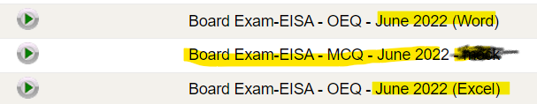

Exemplar Questions
In preparation for the exam, we have made an electronic example exam paper available to you. This exam closely resembles conditions under which you will write the actual exam.

Although you were provided with a larger set in the exam prep guide, we have extracted a smaller sample set of those questions, made improvements, and uploaded them to the examination platform.

Upon logging in, you will see 2 exemplar assessment loaded for you to practice on.

Questionmark Login details
Login URL
Using Chrome:
User Name: | Refer to the covering email (Hint: CISA Membership Number or Your ID #)
Password: | This will be emailed to you separately.  If you choose to change your password or reset it, please keep it handy.

Instructions to access the exam system Questionmark and the exemplar assessment:
- Please use Internet Explorer when accessing the exam. It may not display correctly in other browsers.
- Click on the following link to access the exam User account | 607701 (questionmark.eu): Your log in details appear below:
- Type your Username & Password to start the exam.
- After completing all the questions, a “submit” button will be available in the bottom right-hand corner. Please note that the answers are only submitted to the system once the “submit” button is clicked. Once the exam has been submitted, it can’t be retrieved.
- After your answers are submitted you can click on the “next” button to receive feedback on incorrect answers. You should be able to use the electronic feedback feature on each question to provide us with any feedback you wish to send to the administrators.
- You are allowed an unlimited number of submissions from 17 August 2022 until 12 October 2022.

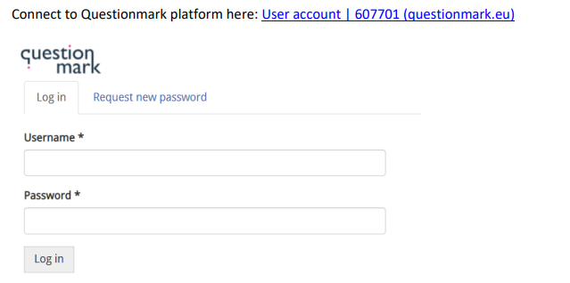

Should you encounter a problem on the day of the exam and/or won’t be able to attend, please contact the Compliance Institute immediately at Tel: 011 642 7974 and email us at professionalism@compliancesa.com .

Yours in compliance

Professionalism Team
Compliance Institute Southern Africa

Annexure
Technical considerations for Questionmark

- Windows
- Word
- Teams
- Internet access : (chrome or edge)
- Email
- Use of connecting via a VPN is not recommended as interaction with Questionmark software could be obstructed
- Stable internet access & a backup connection if possible (a minimum of 2mbps internet speed
- Power & internet connectivity - backup
- Team viewer for QCTO access for EISA student – approval to get approval to remote into their machines
- Onboard camera – for virtual proctoring
- Mic in working order
- Teams chat feature working
- Teams incoming video and chat must be enabled

Connect to questionmark platform here: User account | 607701 (questionmark.eu)

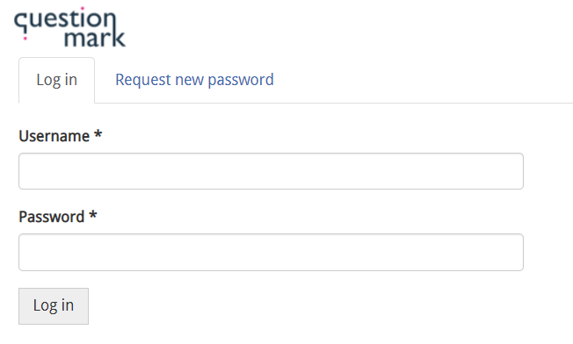

ANNEXURE
Board Exam / EISA Exam
Exam Rules and Instructions

Exam rules
General
Examination rules come into effect as soon as the candidate enters the examination venue or are connected with the online invigilator. The invigilator will commence the exam session with the reading of the exam rules. Candidates must submit in all matters to the directions and rulings of the invigilator.
The exam invigilation sessions will be recorded for record purposes.

Exam rules
- Candidates have the stipulated time to complete the examination:
- MCQ: 2 hours
- OEQ: 1hr30min for the exam PLUS a minimum reading time of 15 min (this will always be confirmed on exam day)
- No extra screens are allowed, unless arranged prior to the exam by permission. In the alternative the candidates are recommended to use a device with a screen size of with at least 15 inches so that they can split the screen.
- No cell phones or other electronic devices (including memory sticks or other data storage devices) are allowed in the examination room.
- No reference material, templates, or other aids may be used, except for nonprogrammable calculators.
- The internet may not be accessed at any time.
- All bags must be placed in the front of the examination room.
- Candidates that write online must have a clear surface around the laptop.
- ID books must be placed on the desk, or shown to the invigilator as soon as contact is made online.
- The examination paper and script book are to be turned in with the answers. (where applicable)

The exam system and paper
- The exam paper consists of multiple-choice questions and an open-ended question.
- The invigilator will explain the working of the exam system (including the assessment navigator).
- Candidates are required to answer their examination on the computer provided (multiple choice and open-ended questions).
- The open-ended question may also be answered in handwritten format in the script book provided. (when applicable)
- Candidates will be provided with a password to open the open-ended question paper.
- As a precautionary method, candidates are reminded to manually save at least every 10 minutes as demonstrated by the invigilator.
- If the candidate is not ready to submit by the time s/he starts on the open-ended section of the exam, the candidate should save the MCQ section before moving on to the open-ended question section.
- Candidates should ensure that they have submitted both the MCQ and open-ended sections before leaving the examination room.

Beginning the examination
- Candidates may not enter / open the examination sections until instructed to do so by the Invigilator.
- Candidates may not begin writing or accessing the examination system until the Invigilator has completed the announcements and officially started the examination.

Completion of examination materials
- Candidates are required to write their answers in English.
- Hard copy: Candidates must ensure that their name and CI membership number are entered on the front of each script book or on the electronic document provided. (where applicable)
- Hard copy: No part of the script book should be torn off or separated in any way. (if applicable)
- Hard copy: Candidates should write on both sides of the page. (if applicable)

Conduct during the examination
- Any candidates requiring assistance during the examination must raise their hand and wait for an invigilator to respond to them.
- Candidates should not leave their desk and walk about the room during the examination.
- No-one is permitted in the Virtual exam room while the exam is in progress.
- Communication of any kind with other candidates in the examination venue or at home/office is forbidden before, during and after the examination.
- Invigilators may not be asked questions concerning the content of the exam during the exam.
- A candidate whose conduct is, in the opinion of the Invigilator, disturbing to other candidates and who persists in such behaviour after receiving a warning from an invigilator shall be required to leave the examination venue.
- In the event of an emergency, candidates must follow the instructions given by the invigilators and must refrain from talking during an evacuation.
- No other act that appears to violate examination ethics will be permitted.
- In the case of an extended interruption during the exam due to failure of an internet connection, network, power failure or the like:

- The invigilator may, at his/her discretion, allow the candidates to choose whether they
wish to continue writing after the interruption, or to reschedule the exam at no additional
fee.
- If the candidate then fails the exam, the candidate will not be able to object to the
outcome citing the interruption as a reason for the appeal.
Leaving the examination
- No candidate may leave the examination venue during the first 30 minutes or the last 15 minutes of the examination, except in exceptional circumstances and at the discretion of the invigilators.
- Candidates wishing to leave the examination (temporarily or otherwise) must raise their hand and wait for an invigilator to acknowledge them. And may advise in the chat for Teams, that they need to go to the bathroom.
- Candidates wishing to return to the examination may not leave the examination room unsupervised.
- Your bathroom breaks are at your discretion, and you may have up to 3 breaks and you will be timed.
- If a candidate finishes before the full time has lapsed, s/he should alert the Invigilator by raising their hand, ensure that they have submitted their responses on the system, turn in all materials and leave the room/Team site quietly.
- The invigilator will announce regular time intervals and when time has expired.

At the end of the examination
- All candidates must stop writing when instructed to do so by the Invigilator.
- The invigilator will then instruct all candidates to submit their answers on the system if they have not done so already.
- An invigilator will collect the examination materials. Candidates should be aware that any examination script or related material that is removed, even inadvertently, from the venue without authority will be deemed invalid.
- Candidates may only leave after the invigilator has confirmed that they have submitted their answers.
- Breaking any of these rules could result in losing the privilege to sit this (or future) CISA examinations.

Instructions to candidates:
The exam consists of 2 sections, i.e. multiple choice questions (MCQ) and an open ended question (OEQ).

These are written in the same sitting.

You may start with any question section you choose; MCQ or OEQ.

You will receive 2 Teams invitations:
- 8:30 – 8:50: Opening Exam room for Rules & Testing
- 8:50 – 13:00: Your exam Room for registration and starting your exam. The exam clock counter only starts once you start the exam.

Date: | 13 October, 8:30 – 13:00
Time: | 8:30 – 8:45 Testing, Exam rules and procedures  8:50 - 9:00 Registration  9:00 – 13:00 Exam for MCQ and OEQ  Guidelines for exams:  MCQ: 2 hours  OEQ: 1hr30min for the exam PLUS a minimum reading time of 15 min (this will always be confirmed on exam day)  Submit exams as soon as you are complete with each section and advise the invigilator when you have submitted. Do not close the submission window until the invigilator tells you they received your exam submission.  After submitting the OEQ on the exam system, please email your completed paper to professionalism@compliancesa.com and your invigilator.
Venue:  CISA Team: | Remotely via Teams  Compliance Institute Southern Africa  Grayston Ridge Office Park, Block B  Lower Ground Floor  144 Katherine Street  Sandton

Your invigilator will do the following time checks over chat and may do so over MIC but will try to limit verbal communications:
9:00 -11:00 – Every hour on the hour (For 1st 2 hours)
11:00 – 12:00 – Every 30 minutes
12:00 – Every 15 minutes

Testing:
If you have any issues, please advise so that we can resolve it and then we will send you off to your exam room.
- Teams
  - MIC
  - Camera stays on
  - Chat

- Team viewer (EISA only)

- Email
  - Received both and
  - Can open the Word and/or Excel documents with password in Chat now

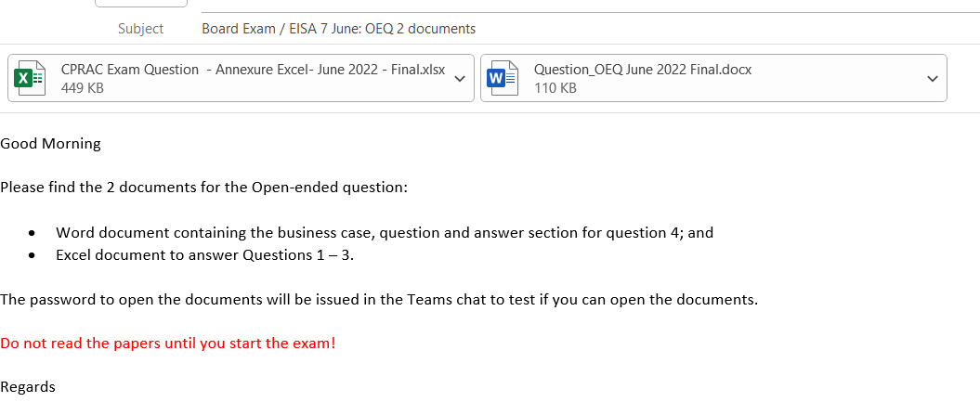
- Questionmark
  - Log in
  - If you can see 3 assessments in the Dashboard on the Home page

Exam Navigation & Instructions:
This assessment is a closed book exam and no handbooks, study material, notes or electronic devices are allowed in the exam room. It is a non-disclosure exam that means that no information regarding the questions and/or content may be disclosed or distributed in any manner or format. No exam papers, booklets, scrap paper, usernames or password may leave the room. All papers to be handed to the invigilator before departure. Also refer to exam rules.

Section 1 – 70 marks (MCQ)
- Consists of Multiple-Choice Questions which are answered on the computer.
- There is a “link” on the desktop that will direct you to the assessment.
- Select the MCQ assessment and click on the “play” button to enter the assessment.
- Enter your username and password you received when you entered the exam room.
- After you have logged in, you will be prompted to enter a monitor username and password.
- The invigilator will make the monitor password available once all candidates are logged in.
- You can move to “next question” and go back to “previous question” by clicking on the relevant button.
- You can also make use of the “Assessment Navigator” to flag questions should you want to review them later.
- Once you completed the last question, make sure that you click on the “submit” button.
- • You will receive a notification “Thank you for submitting”.

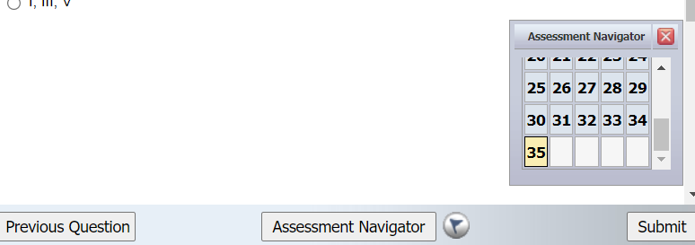

Post your submission completion of the MCQ in the chat window and your invigilator will check the submission with Questionmark Support.

Keep the window open and ONLY close once the invigilator has confirmed that Questionmark received your submission.

Move onto the OEQ Word and Excel papers in the meantime.

Once you select ‘close’ you will go back to the Dashboard screen:

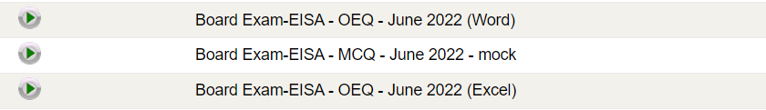

Section 2 – 30 marks (OEQ)
- Consists of an open-ended question with 1 or 2 parts (can change from exam to exam) to allow you to upload the Word and/or the Excel documents separately.

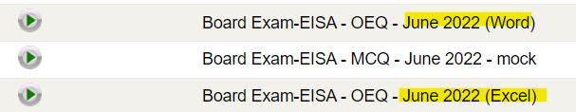

- You will receive the Word and Excel documents over email, both with a password protection.
- You will need to open each document and save it to your desktop or “my documents” as follows:
      - Make use of the following naming convention for the Word document: when you save your question: FIRST NAME, 2nd INITIAL, SURNAME (as per ID document), OEQ1
      - Make use of the following naming convention for the Excel document: when you save your question: FIRST NAME, 2nd INITIAL, SURNAME (as per ID document), OEQ2
- Once completed, your answer it must be uploaded on the system.

- Make sure that autosave is switched on in Word and Excel so that you can save your work as you go through the Question Paper in Word and Answer sheet for Q4; and Excel will be for the Answers to Questions 1 – 3.

- When you are ready to upload your documents. Make sure it has saved 1st, then
Go back to Questionmark and Upload to the “Word” assessment 1st:

On this Assessment: For OEQ WORD

Select “Play” button:

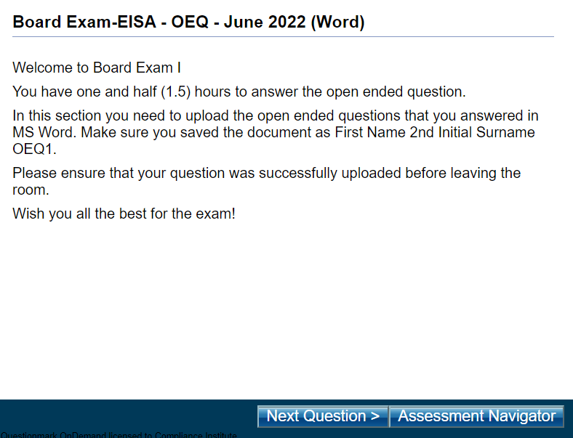

Select Next question.

Then select Browse to find and upload your Word document:
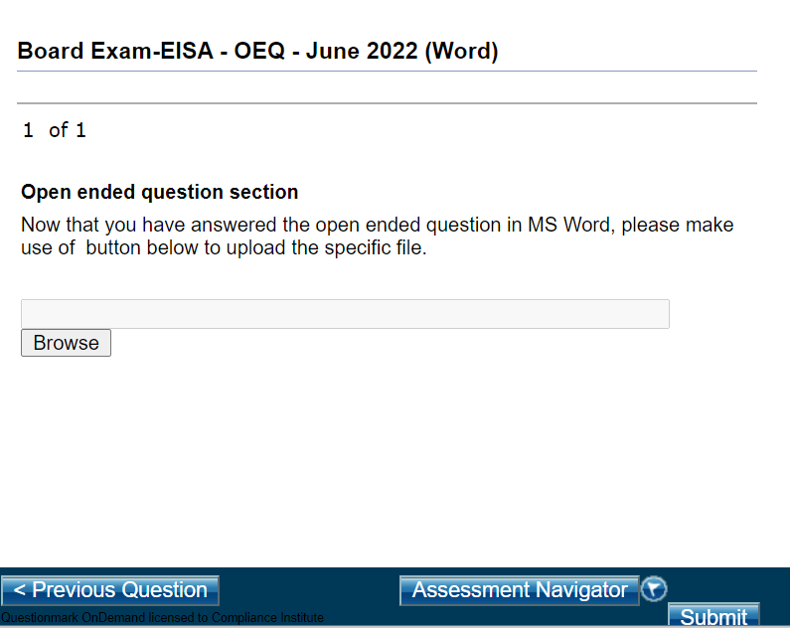

A window will pop up

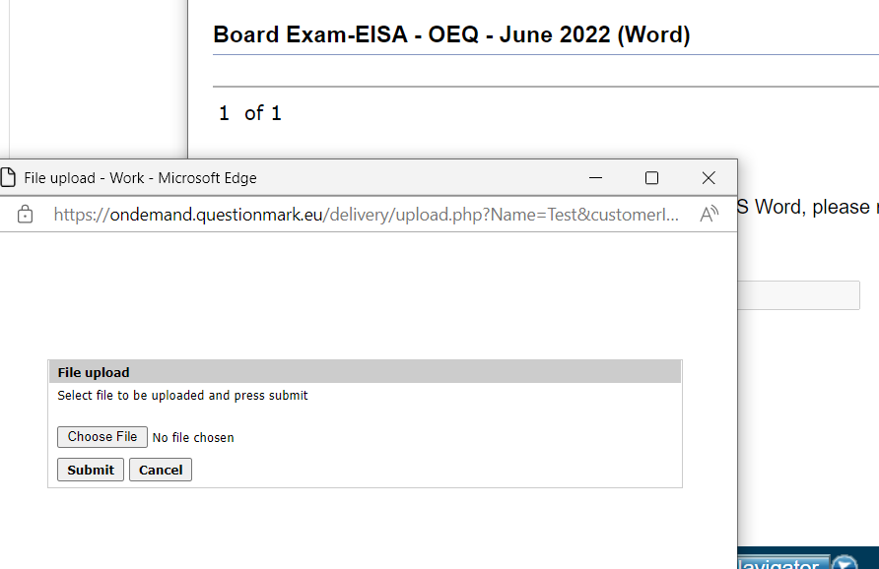

Select choose file to browse for your document and select it, then once it is showing in the window, select Submit in the pop-up window.

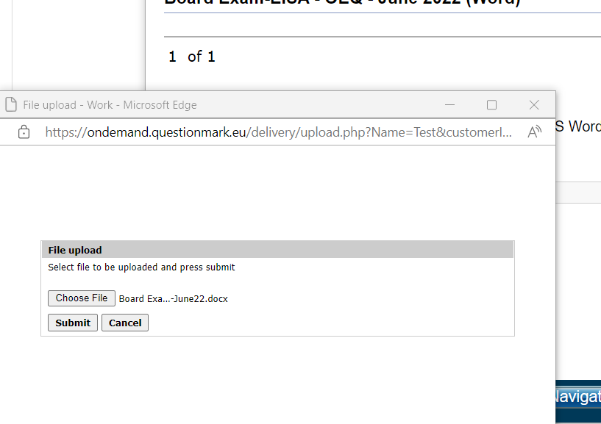

And then close in the pop-up window.

You will then return to the main window and you select Submit on bottom right.
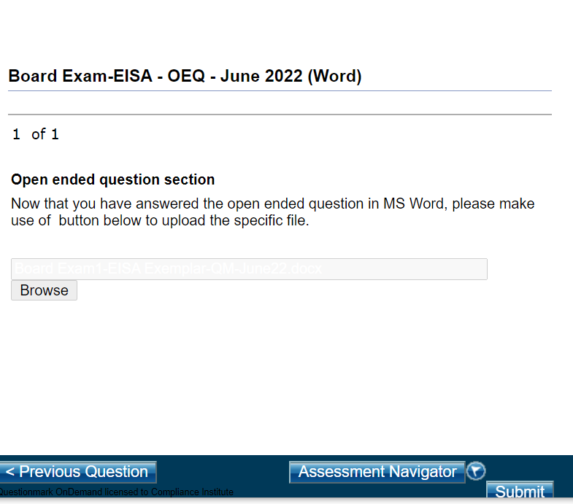

You will see a message that says “Thank you for submitting”.

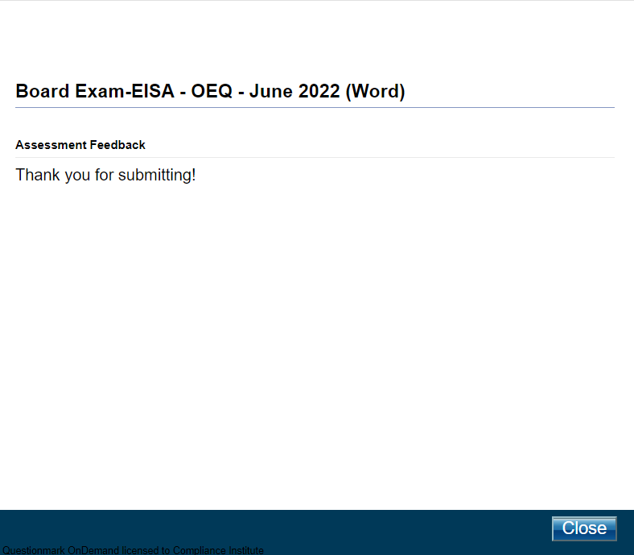
THEN Select close and return to the Home Screen / Main Dashboard to upload the excel document.

On this Assessment: For OEQ EXCEL

Click on the Play button:

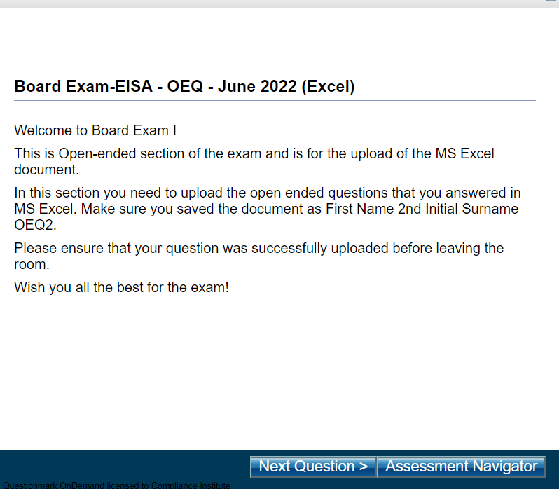

Select Next Question to go to the upload screen:

Then select Browse to pull up the browse pop-up window to find and select your excel document:
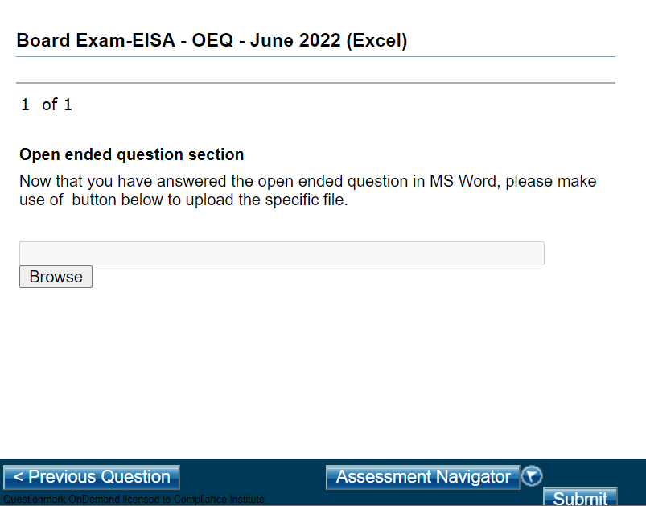

POP-UP Window:
Click choose the file and find your file.

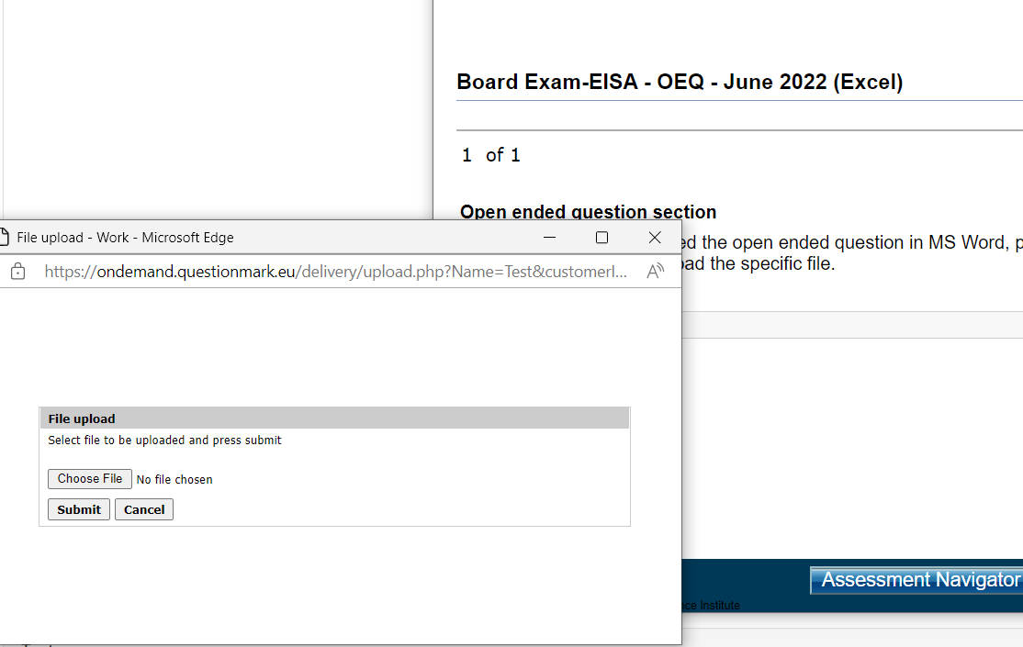

The select Submit on the pop-up window to upload the document:

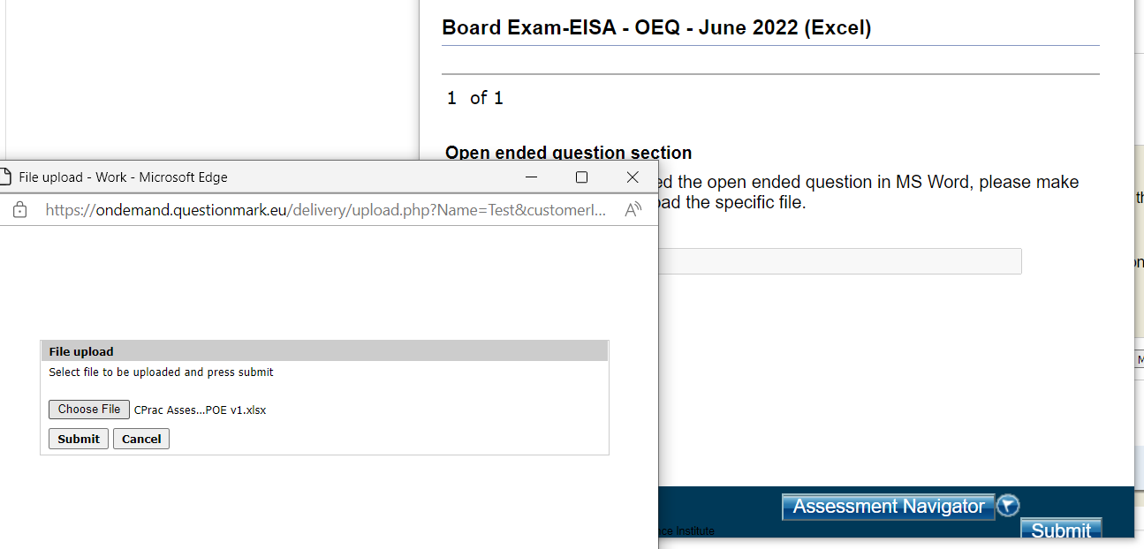

Then select close in the pop-up window to upload the file.

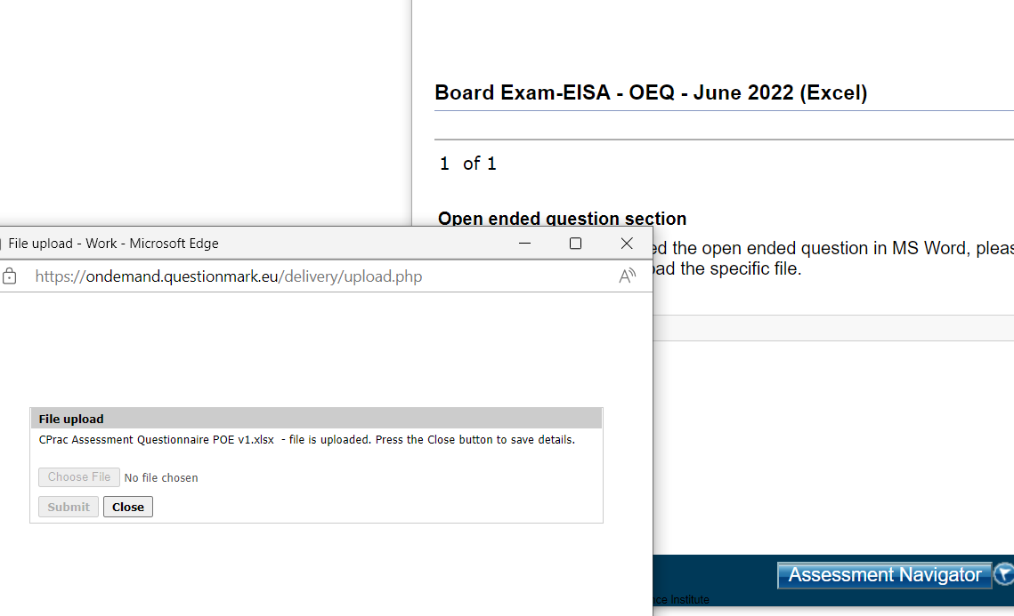

You will return to the main window and will see the progress on the top bar in red and then select submit in the bottom right corner of the screen:

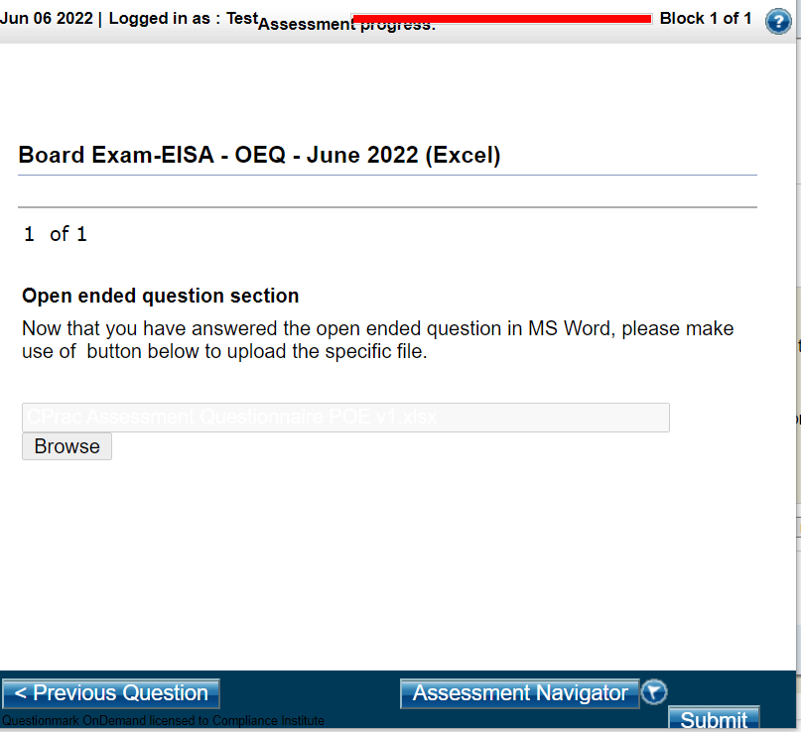

You will see Thank you for submitting.

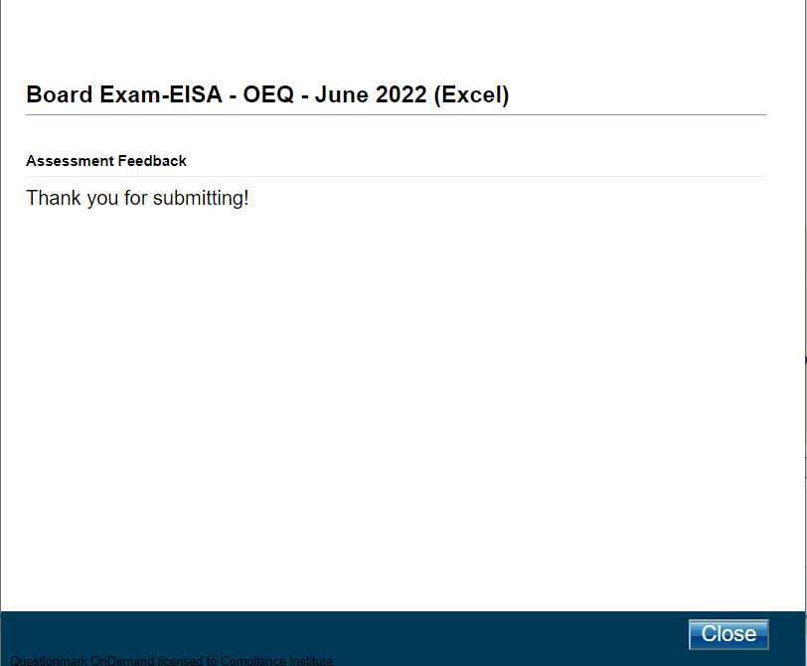

Post your submission completion of both files for OEQ in the chat window and your invigilator will check the submission with Questionmark Support.

Then email both your files to professionalism@compliancesa.com and cc your invigilator (as a backup measure).

When the Invigilator confirms receiving your Questionmark submission and your email, you may leave the Exam Room.

